Installing the RSA Soft Token software

Download the RSA Soft Token software from the following location: http://www.nscorp.com/nsvpnclient and click on RSASoftToken400.zip

Click Open, double click on RSASecurIDToken400.msi, and click Yes

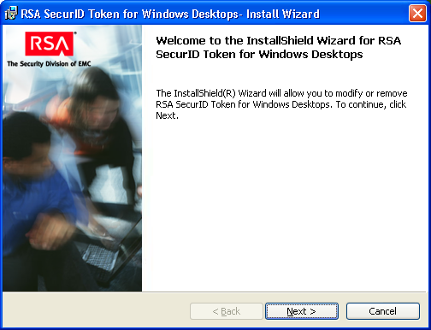

Click “Next”.

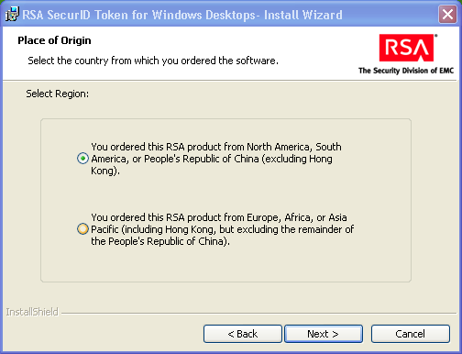
Leave this selection as is – click “Next”.

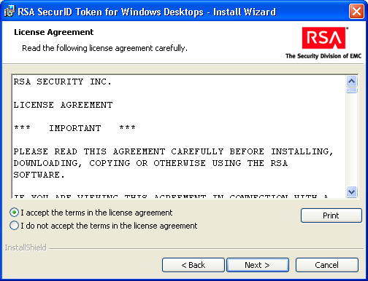
Click on I accept the terms in the license agreement and click “Next”.
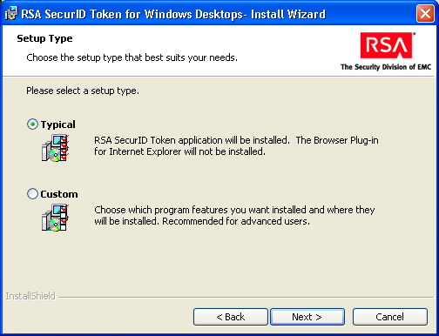
Leave on “Typical” – click “Next”, and then click “Install”.

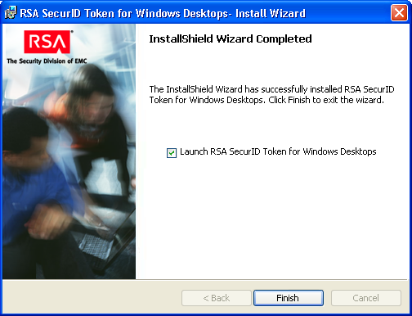
Check “Launch RSA SecurID Token for Windows Desktops” and click “Finish”.
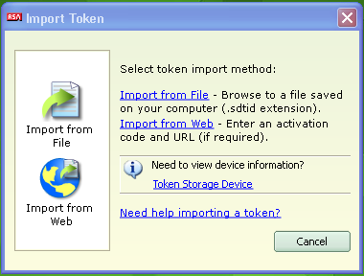
Click “Import from File”.

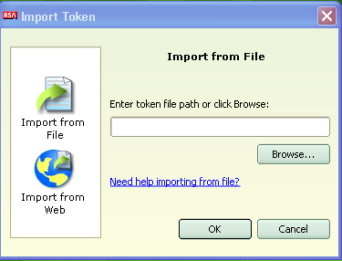
Click “Browse”, and browse to the location of the .sdtid file that was emailed to you by the NSS Helpdesk.

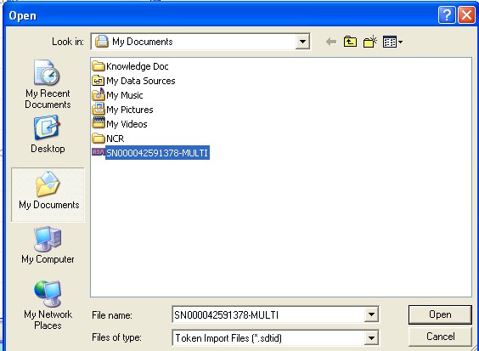
Click on the .sdtid file once it is located and click Open

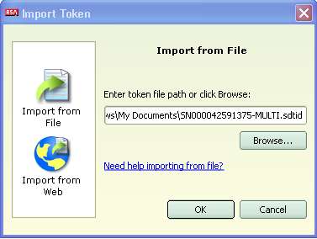
Click “OK”.

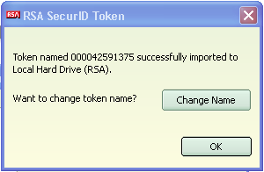
Once you receive the success message, simply click “OK”.
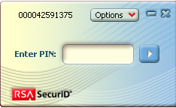

You will be prompted by the software SecurID to create a PIN. You do NOT want to create a PIN at this point, as your PIN has not yet been set with the server. Simply click the arrow for now to continue.

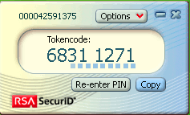

You will now see a Tokencode displayed on the SecurID. You will use this Tokencode to log into the Cisco VPN. As a shortcut, you can simply click the “Copy” button and then paste the Tokencode into the Password field on the Cisco VPN Client and click OK (or hit the Enter key)

The Cisco VPN client will prompt you to create a new PIN. This PIN can be between 4-8 characters and can contain only numeric characters (0-9). Type the PIN in a second time to verify it and click OK. Once the new PIN is accepted, you can exit the Cisco VPN client.

The last step is associating the new PIN with your SecurID Soft Token.

Click “Re-enter PIN”.

Simply type in the PIN you just created and click the arrow. At this point, the TOKENCODE should change to PASSCODE in the display. At this point, the PASSCODE number will always be the only number typed or pasted into the Cisco VPN Client password field.

Once you have created your PIN, you are ready to begin using your SecurID Soft Token with the Cisco VPN Client or Citrix Access Gateway (DAC.NSCORP.COM).

Once again, you can simply hit “Copy” to copy the current passcode for easy pasting into the VPN.

